**LOW LIGHT IMAGE ENHANCEMENT**

**ASSIGNMENT 1**

**Introduction**

The goal of low light and night vision image augmentation is to produce better photos taken in situations where there is little to no visible light. Details are frequently difficult to see in such photographs due to noise, blurriness, and low contrast. However, these images are sometimes enhanced to create images that are more recognized and clear. Histogram equalization technique is used to improve low light and night vision images. These techniques help recover details, improve brightness, and make the scene more comprehensible for crucial applications like autonomous driving, security, and surveillance.

**Abstract**

This project illustrates a thorough method of improving quality of low-light images by combining techniques such as ***histogram equalization, CLAHE (Contrast Limited Adaptive Histogram Equalization), bilateral filtering, gamma correction*** and ***unsharp masking***. To enhance the overall brightness and contrast, the procedure starts with loading a low-light image and independently applying histogram equalization to each of its RGB channels. After that, the improved image is exposed to CLAHE, which improves local contrast even more while avoiding noise overamplification.

The final image is subjected to a bilateral filter in order to preserve edge integrity while lowering noise. The output is sharper and more defined as a result of this step's effective smoothing of homogeneous regions without sacrificing edge definition. Ultimately, gamma correction is applied to fine-tune the image's brightness and contrast, providing more precise control over the visual quality. To further enhance sharpness, unsharp masking, a technique that emphasizes edges and adds clarity by blending the original image with a blurred version of itself, is implemented. This final step helps create a more distinct and detailed appearance, enhancing features while maintaining balance between smoothness and sharpness.

The visual quality of low-light photos is greatly enhanced by this multi-step enhancement pipeline, which makes it appropriate for a wide range of image processing applications.

**Link to dataset:** <https://drive.google.com/file/d/1MLeLUf8H4CqvWUoSn5TePqRWznueWvig/view?usp=sharing>

**Current Real Time Applications for low-light image dataset :**

Autonomous Driving and ADAS: Advanced Driver Assistance Systems (ADAS) and Autonomous Driving Systems (ADS) are two of the main real-time applications for low-light filtering. RGB cameras, which are frequently utilized in these systems, have trouble seeing at night. To improve visibility in low-light conditions, recent technologies like VELIE (Vehicle-based Efficient Low-light Image Enhancement) employ deep learning methods as Swin Vision Transformer and U-Net. For driving safety in low-light circumstances, this enhances object detection and environmental perception with minimal processing cost and real-time performance (MDPI).

**FILTERS USED**

The **Bilateral filter** is the main filtering method employed in the code that is provided. The Bilateral Filter is a smoothing filter that is non-linear, preserves edges, and lowers noise. The bilateral filter takes into account both the spatial distance between pixels and the intensity difference (color similarity) while averaging pixel values, in contrast to conventional smoothing algorithms that blur all pixels uniformly. As a result, pixels that are closer together or have distinctly different colors will not affect each other's values as much, enabling the filter to reduce noise while maintaining edges and other crucial aspects of the image.

The **Unsharp Masking technique** is the primary sharpening method employed in the code provided. Unsharp masking is a technique used to sharpen images by enhancing the edges and fine details. It works by creating a blurred (unsharp) version of the image, subtracting it from the original, and then adding the result back to the image. This process amplifies the contrast at edges and fine structures. Unlike conventional sharpening techniques that uniformly increase the contrast across the entire image, unsharp masking selectively enhances areas with rapid changes in intensity, such as edges. This makes the image appear sharper by making the boundaries between different objects or colors stand out more. In the context of this code, after applying smoothing and contrast enhancement steps, unsharp masking is used to ensure that the final output retains clarity and sharpness, bringing out the finer details and improving the overall quality of the image.

$g_{mask }(x,y) = f(x,y) -\underline{ f} (x,y)$

${ g(x,y) = f(x,y)+ k*g}_{mask }(x,y)$

**IMAGE ENHANCEMENT TECHNIQUE USED**

**1. Histogram Equalization**

**Histogram equalization** is a method in [image processing](https://en.wikipedia.org/wiki/Image_processing) of [contrast](https://en.wikipedia.org/wiki/Contrast_(vision)) adjustment using the [image](https://en.wikipedia.org/wiki/Image)'s [histogram](https://en.wikipedia.org/wiki/Image_histogram). Through this adjustment, the [intensities](https://en.wikipedia.org/wiki/Luminous_intensity) can be better distributed on the histogram utilizing the full range of intensities evenly. This allows for areas of lower local contrast to gain a higher contrast. Histogram equalization accomplishes this by effectively spreading out the highly populated intensity values which are used to degrade image contrast.

$Normalized Histogram: p(k) = \frac{n_{k}}{n}$

The goal of this technique is to improve an image's contrast by shifting the intensity values. With the goal of achieving a uniform distribution of pixel intensities, it stretches the image histogram. To improve the overall contrast, the pixel intensities are remapped to new values by computing the cumulative distribution function (also known as the histogram of intensities).

**2. CLAHE**

CLAHE is a histogram equalization variation that works on specific areas (tiles) of the image as opposed to the full image. Its goal is to enhance local contrast without causing noise in homogeneous areas to be too amplified.

The image is divided into tiles, each of which is subjected to histogram equalization. The tiles are then combined using bilinear interpolation. The term "contrast limited" refers to the histogram's clipping, which prevents noise from becoming amplified.

**3. Gamma Correction**

**Gamma correction** is a [nonlinear](https://en.wikipedia.org/wiki/Nonlinearity) operation used to encode and decode [luminance](https://en.wikipedia.org/wiki/Relative_luminance).

$s =c r_{γ}$

By applying a non-linear modification to the image's brightness, this approach brings out the details in the image's lighter or darker areas. To change the brightness, raise the pixel values to a power (gamma). A picture is brighter when the gamma value is more than 1, and it is darker when it is less than 1.

**Sample Images:**

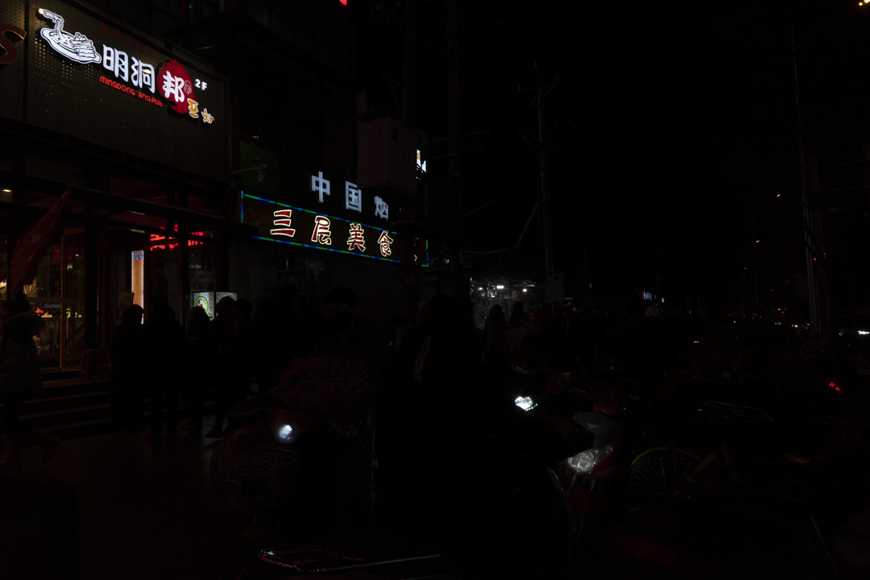

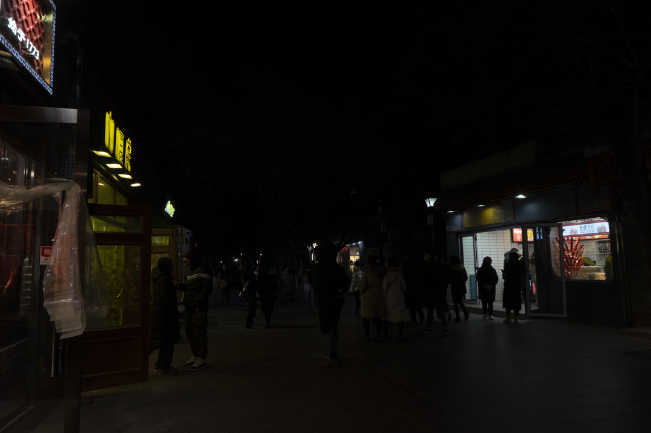

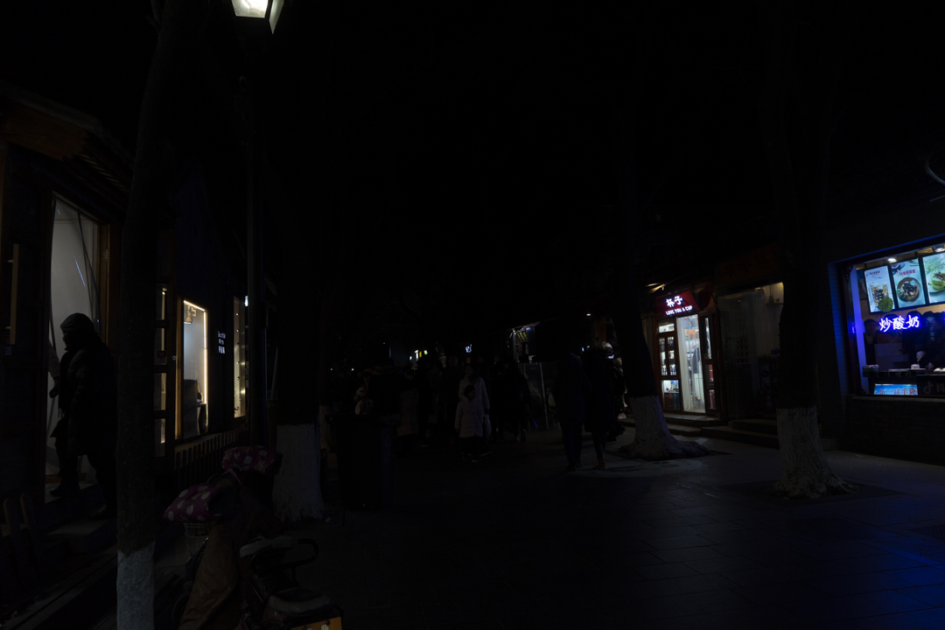

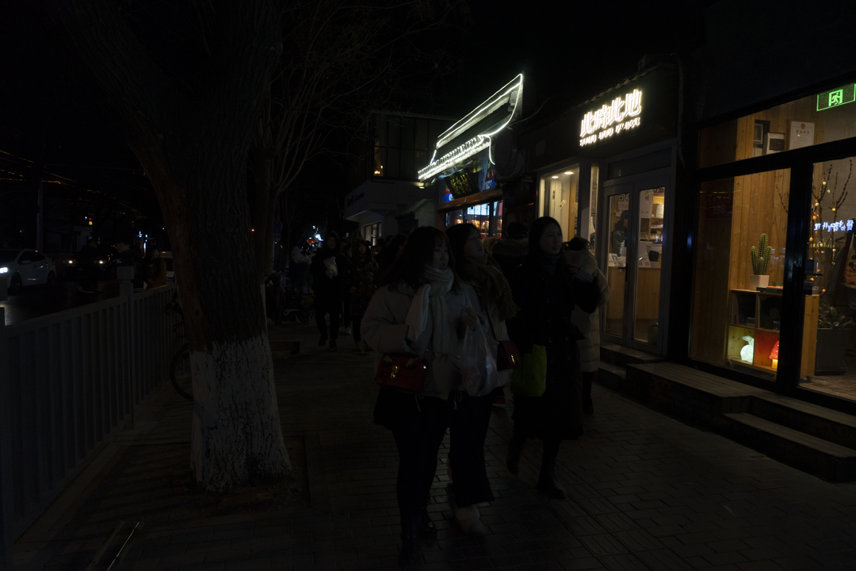

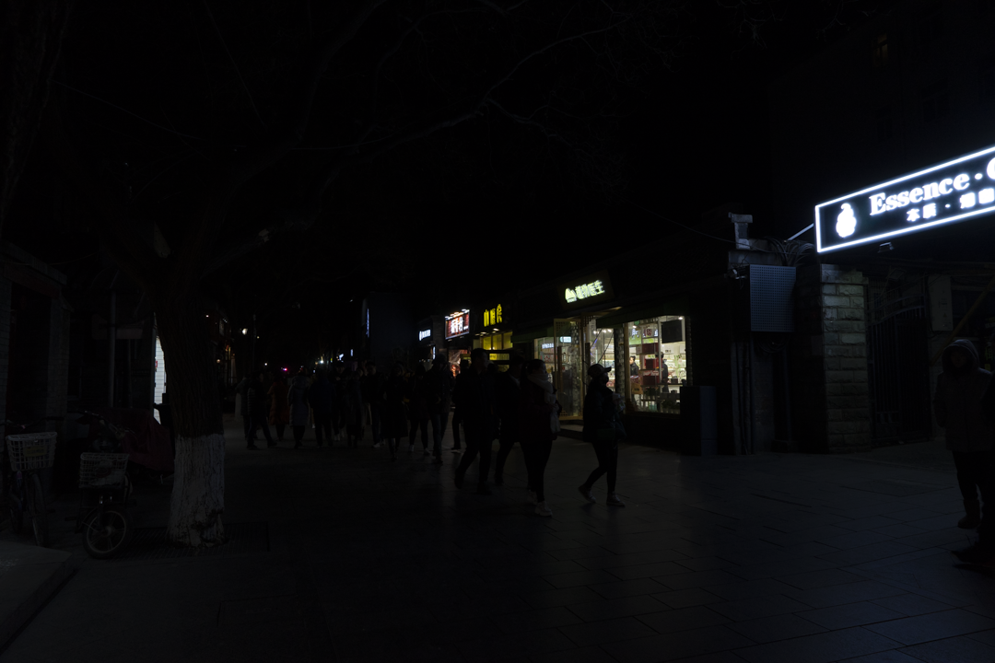

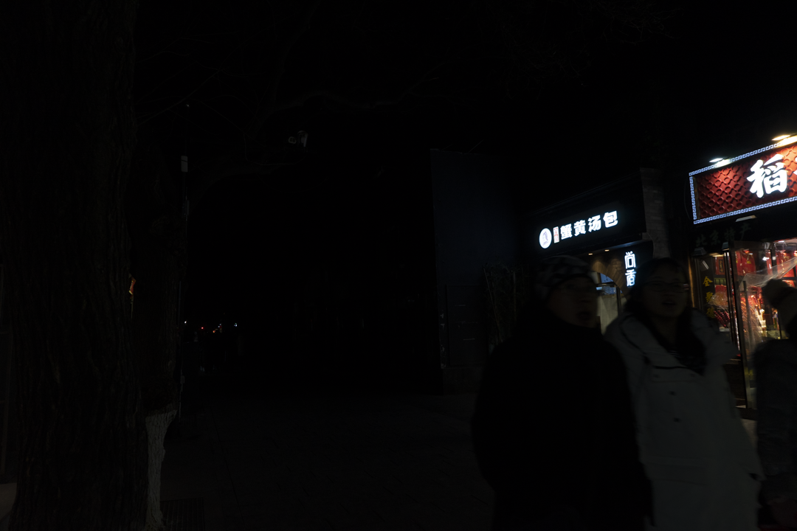

**RGB Scale Image Enhancement (On Original Image) :**

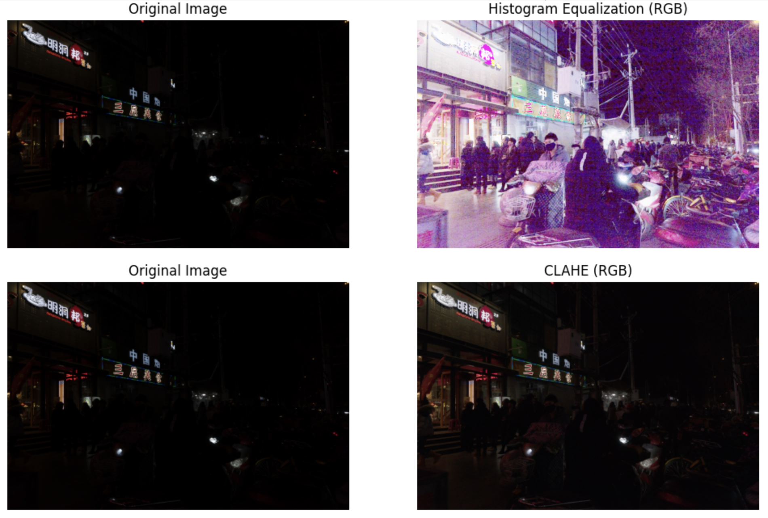

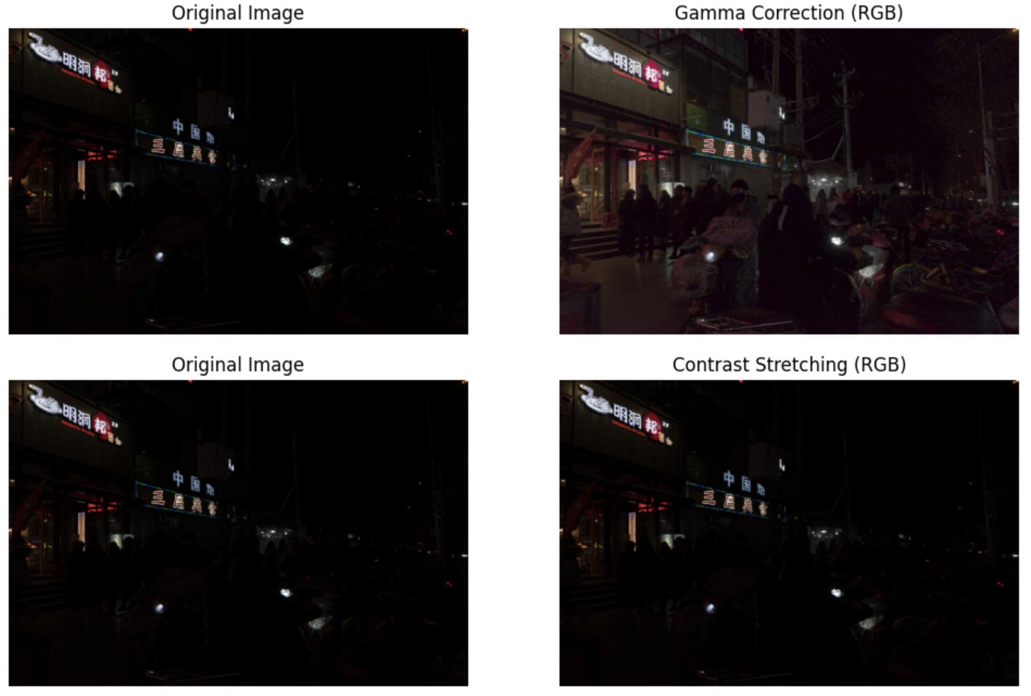





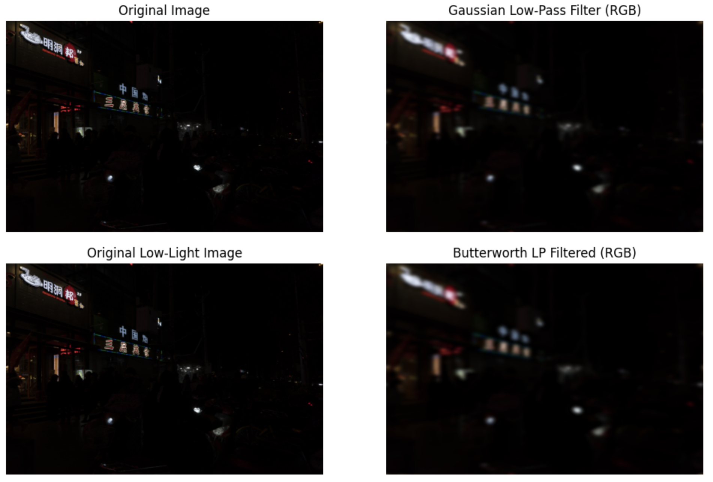

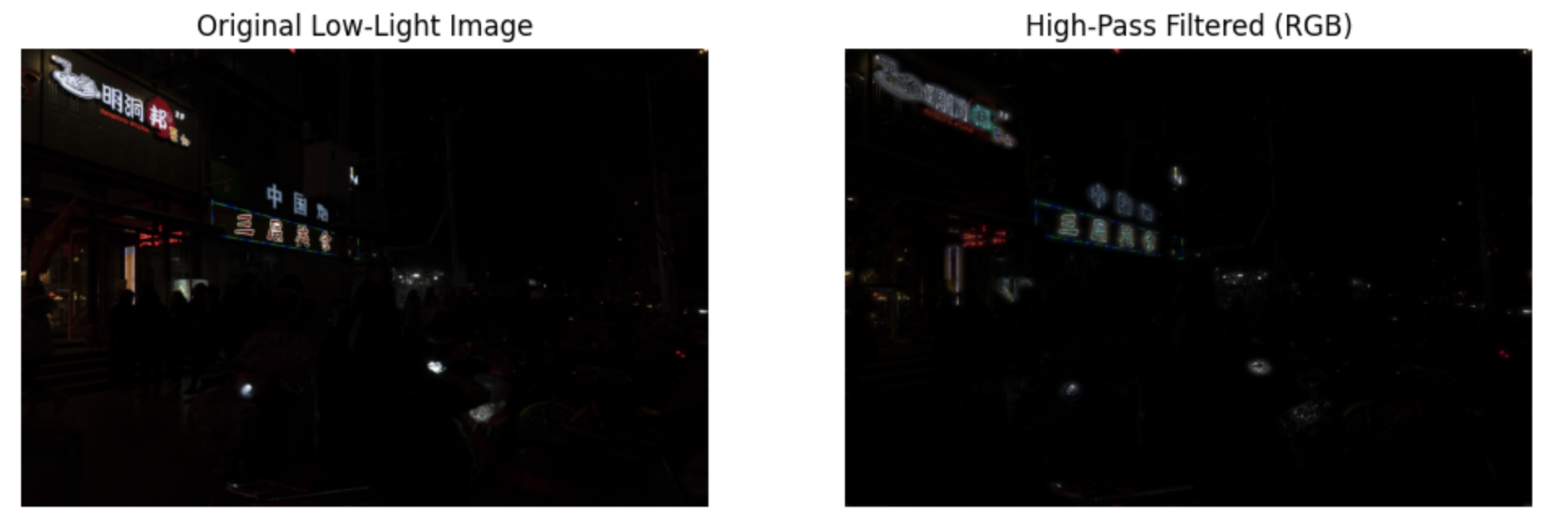

The main motive behind enhancing a low-light image is to make the dark image clearly visible to the human eye. This involves spreading the intensity values of the original image to increase the contrast of the image. Out of all the techniques implemented, histogram equalization does that the best. Hence, the histogram equalized image is chosen for further enhancement.

**Image Enhancement on the Histogram Equalized Image:**

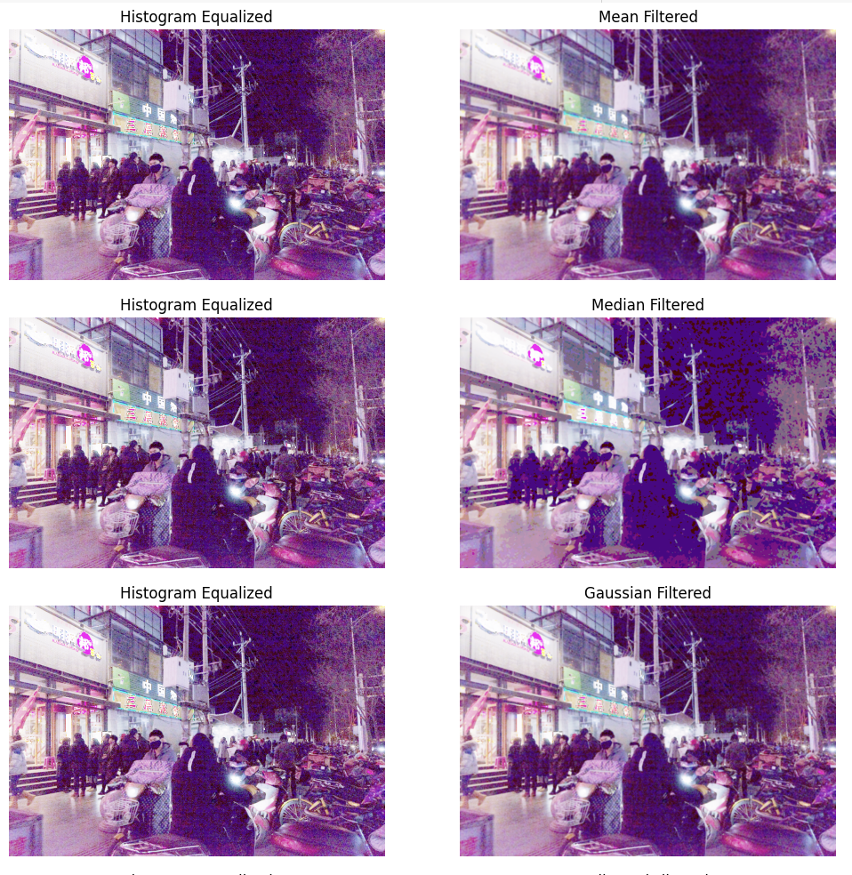

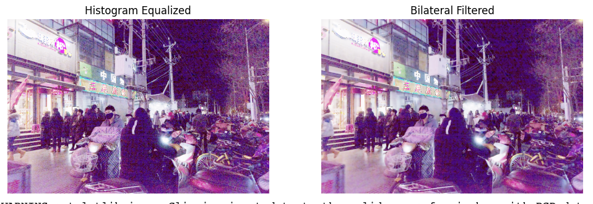

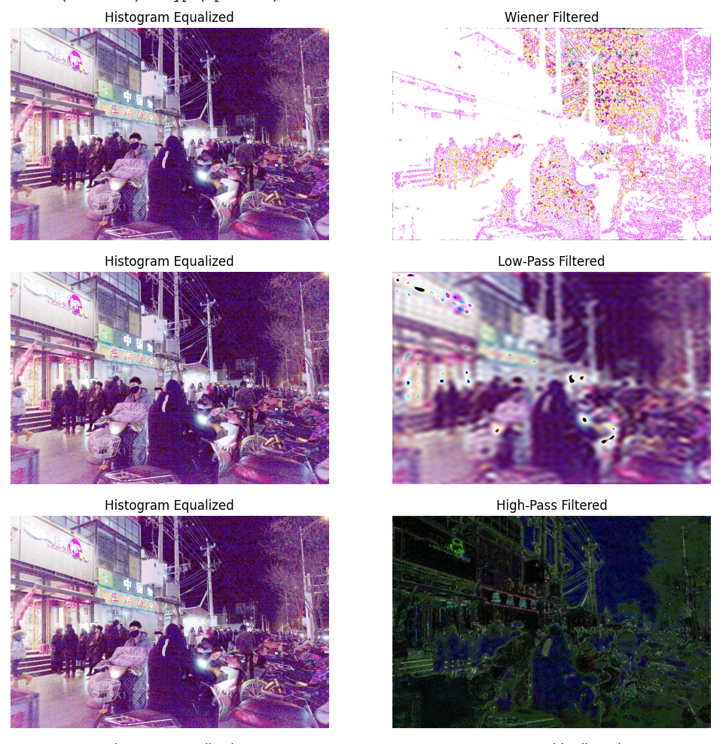

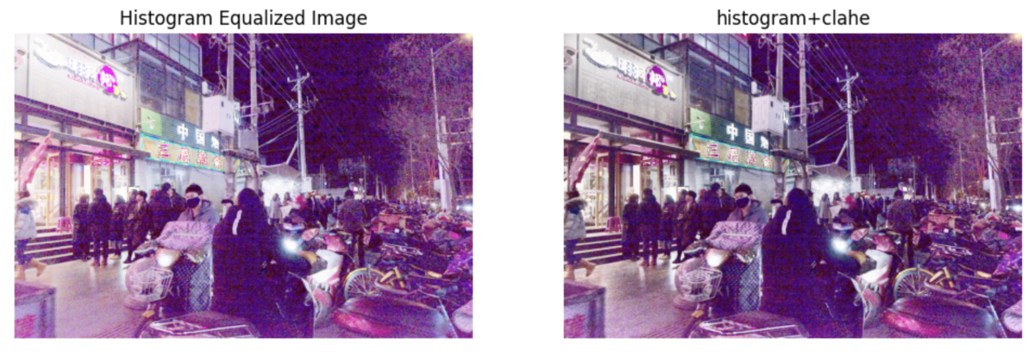

A histogram equalized image might result in over-enhancement of certain areas in the image. To minimize/prevent over-enhancement, CLAHE is preferred over all the experimented spatial and frequency domain techniques because it enhances contrast locally, controls noise and preserves fine details. Other filters used here do not result in sufficient image contrasting. hence making CLAHE a robust method for improving image quality while maintaining natural appearances.

**Image Enhancement on the CLAHE Image:**

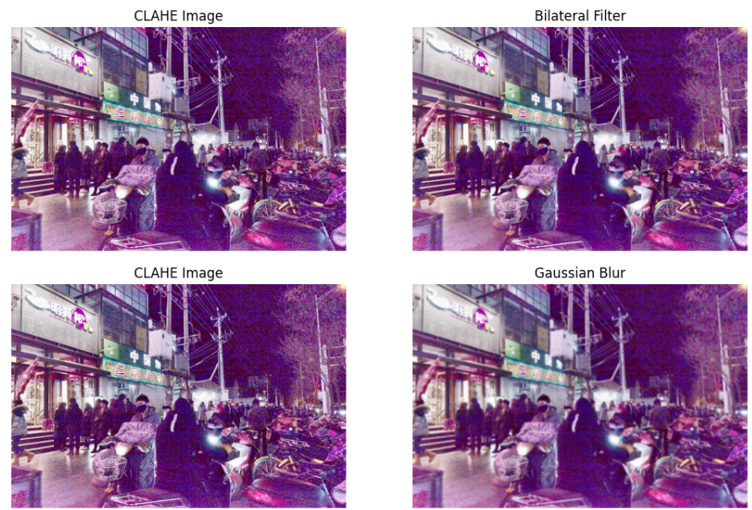

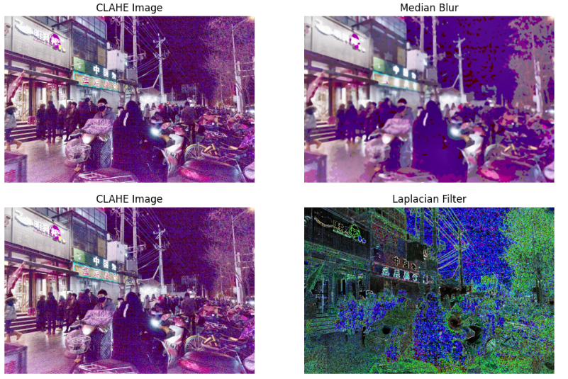

Low-light images typically have poor contrast and significant noise. After applying CLAHE, which boosts contrast, noise may also be enhanced. The bilateral filter selectively smooths homogeneous regions while preserving edges, making it a good post-CLAHE enhancement technique. It ensures that the noise introduced by CLAHE is minimized while keeping important structures intact.

**Image Enhancement on the Bilateral Image:**

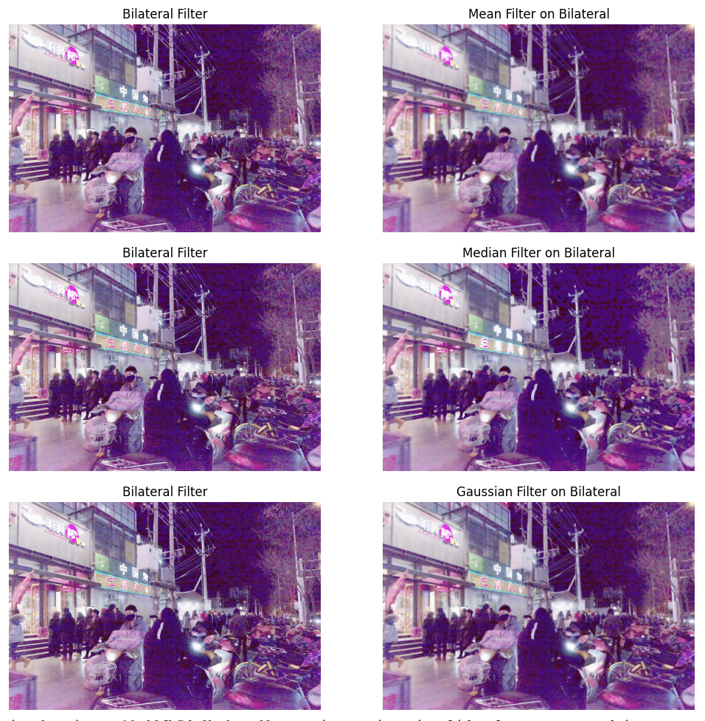



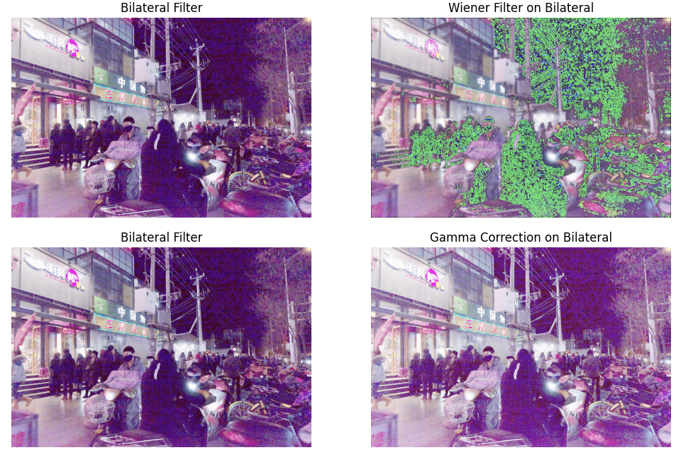

Gamma correction is used after bilateral filtering because it can finely adjust the brightness and contrast in a non-linear way. It enhances the visibility of darker regions without amplifying noise or overexposing bright areas, resulting in a natural-looking image. Other filters like the mean, median, and Gaussian filters are designed for noise reduction or smoothing, but they don’t address the perceptual brightness or contrast adjustments that gamma correction provides.

**Image Enhancement on the Gamma Image:**

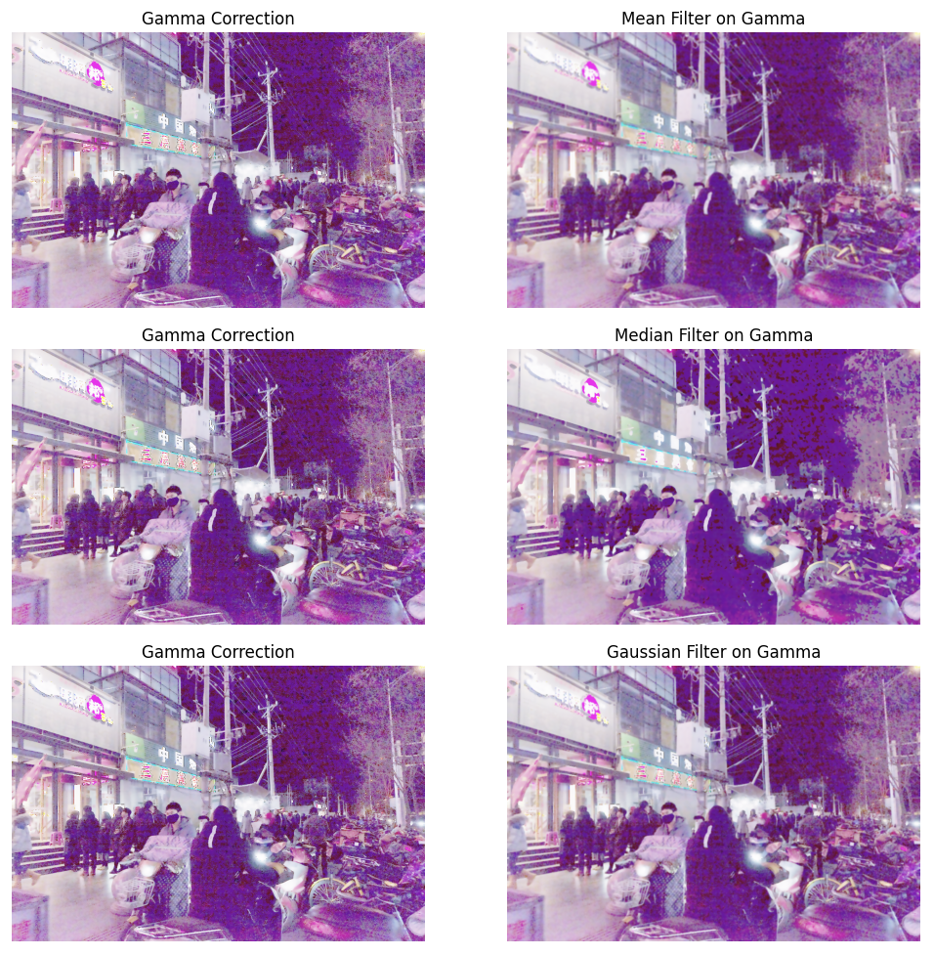



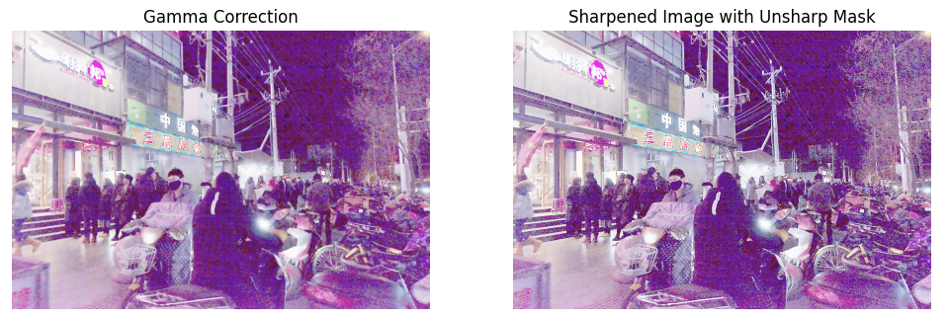

Now that the image is free of noise, it becomes necessary to highlight the image features. This is where sharpening techniques come into picture. Unsharp masking is applied after Gamma correction because it specifically targets edge and detail sharpening, making the image appear crisper and more defined. This is crucial after noise reduction and contrast enhancement steps, where slight blurring may occur.

**Pipeline of techniques applied:**

***Original Low-Light Image → Histogram Equalization → Contrast Limited Adaptive Histogram Equalization (CLAHE) → Bilateral Filter → Gamma Correction → Unsharp Masking***

On working with various values for the parameters of each of the techniques employed, we finalized on the following parameter values :

* CLAHE: Clip Limit- 10.0, Tile size- 10x10
* Bilateral Filter: Diameter of pixel neighbourhood- 2
* Gamma Correction: Gamma value- 1.2 (Ideal for low-light images)
* Unsharp Masking: Strength- 1.5

**Code:**

**import cv2**

**import numpy as np**

**import matplotlib.pyplot as plt**

**# Display function for side-by-side comparison**

**def display_images(original, enhanced, title1, title2):**

**plt.figure(figsize=(12, 6))**

**plt.subplot(1, 2, 1)**

**plt.title(title1)**

**plt.imshow(cv2.cvtColor(original, cv2.COLOR_BGR2RGB))**

**plt.axis('off')**

**plt.subplot(1, 2, 2)**

**plt.title(title2)**

**plt.imshow(cv2.cvtColor(enhanced, cv2.COLOR_BGR2RGB))**

**plt.axis('off')**

**plt.show()**

**# Load the image**

**image = cv2.imread('0.png') # Use the path to your image**

**# Step 1: Split the image into R, G, and B channels**

**r_channel, g_channel, b_channel = cv2.split(image)**

**# Step 2: Apply histogram equalization to each channel separately**

**r_eq = cv2.equalizeHist(r_channel)**

**g_eq = cv2.equalizeHist(g_channel)**

**b_eq = cv2.equalizeHist(b_channel)**

**# Step 3: Merge the equalized channels back into an RGB image**

**hist_eq_image = cv2.merge((r_eq, g_eq, b_eq))**

**display_images(image, hist_eq_image, "Original", "Histogram Equalized Image")**

**# Step 4: Apply CLAHE to the histogram-equalized image**

**lab = cv2.cvtColor(hist_eq_image, cv2.COLOR_BGR2LAB)**

**l_channel, a_channel, b_channel = cv2.split(lab)**

**clahe = cv2.createCLAHE(clipLimit=10.0, tileGridSize=(10,10)) # Reduced clip limit**

**l_channel_eq = clahe.apply(l_channel)**

**lab_eq = cv2.merge((l_channel_eq, a_channel, b_channel))**

**clahe_image = cv2.cvtColor(lab_eq, cv2.COLOR_LAB2BGR)**

**# Step 5: Apply bilateral filtering**

**bilateral_filtered_image = cv2.bilateralFilter(clahe_image, d=2, sigmaColor=50, sigmaSpace=50)**

**display_images(clahe_image, bilateral_filtered_image, "Histogram+CLAHE", "Histogram+CLAHE+Bilateral")**

**# Step 6: Apply Gamma Correction**

**gamma = 1.2 # Adjust the gamma value as needed**

**gamma_corrected_image = np.array(255 * (bilateral_filtered_image / 255) ** gamma, dtype='uint8')**

**# Step 7: Apply Unsharp Masking**

**def unsharp_mask(image, sigma=1.0, strength=1.5, threshold=0):**

**blurred = cv2.GaussianBlur(image, (0, 0), sigma)**

**sharpened = cv2.addWeighted(image, 1 + strength, blurred, -strength, 0)**

**return sharpened**

**# Apply Unsharp Masking**

**sharpened_image = unsharp_mask(gamma_corrected_image, sigma=1.0, strength=1.5)**

**display_images(gamma_corrected_image, sharpened_image, "Histogram+CLAHE+Bilateral+Gamma", "Sharpened with Unsharp Mask")**

**Image 1** :

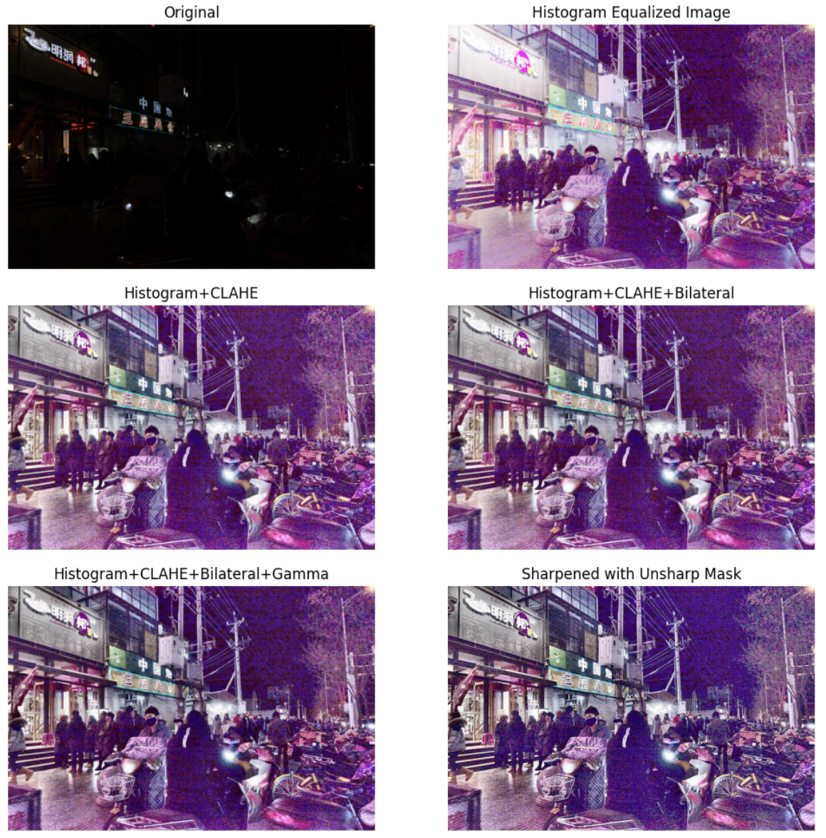



**Image 2:**

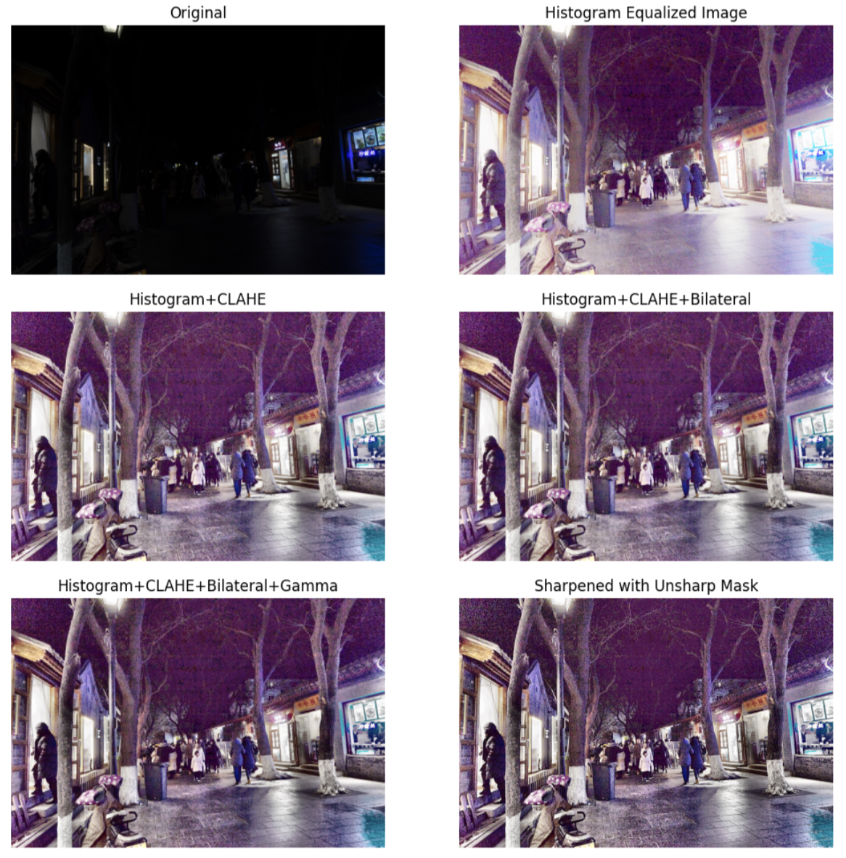



**Image 3:**

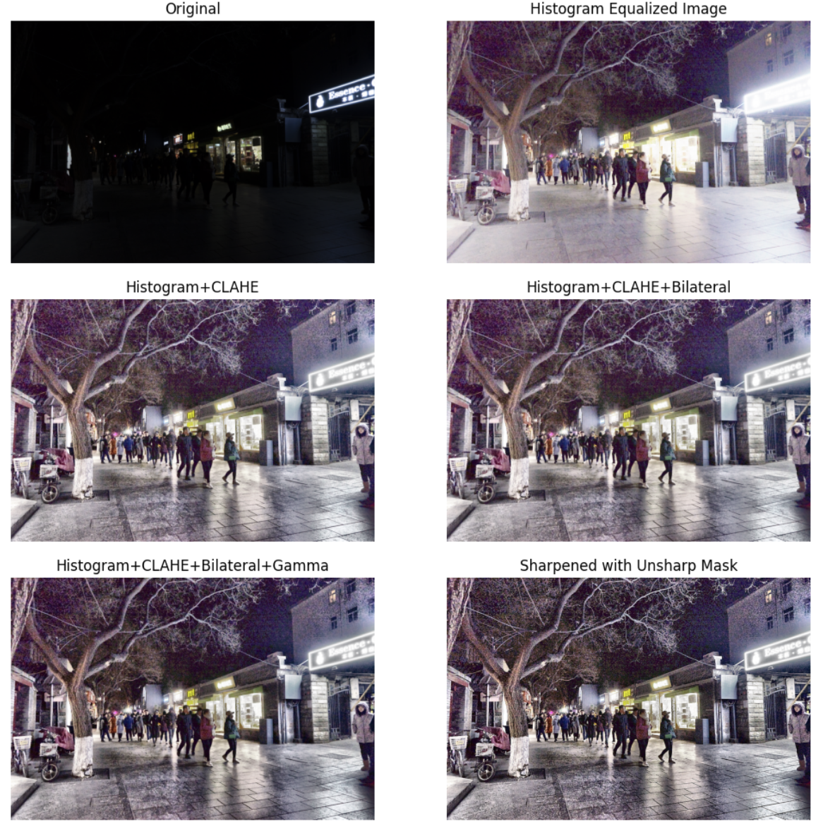



**Image 4:**

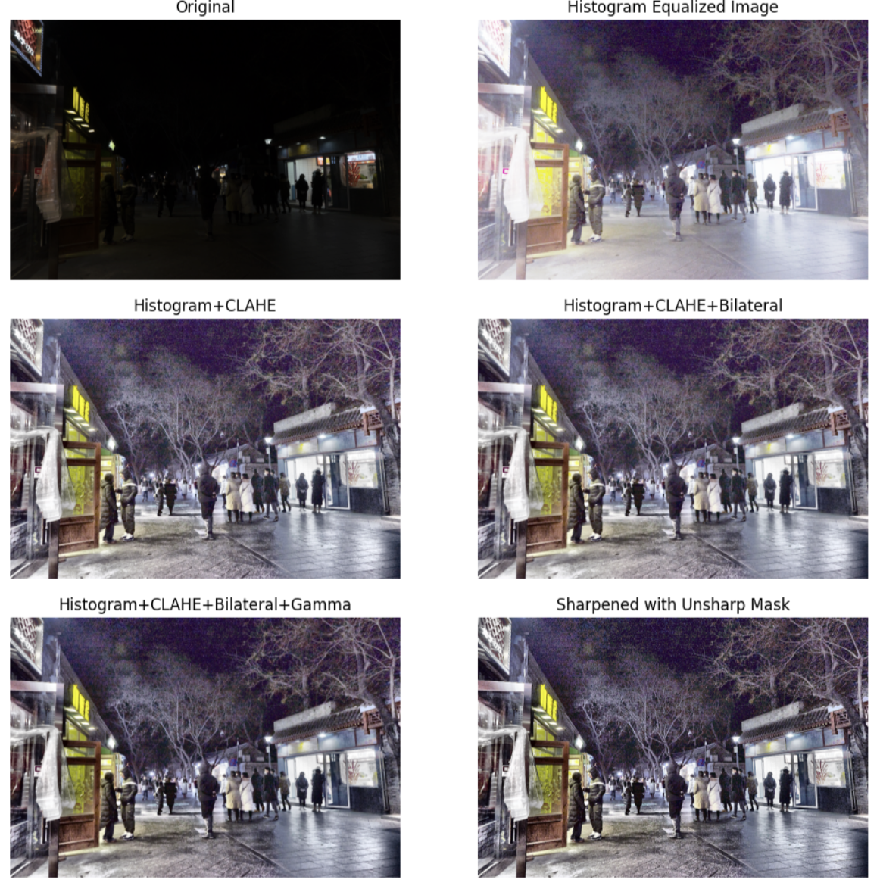



**Image 5:**

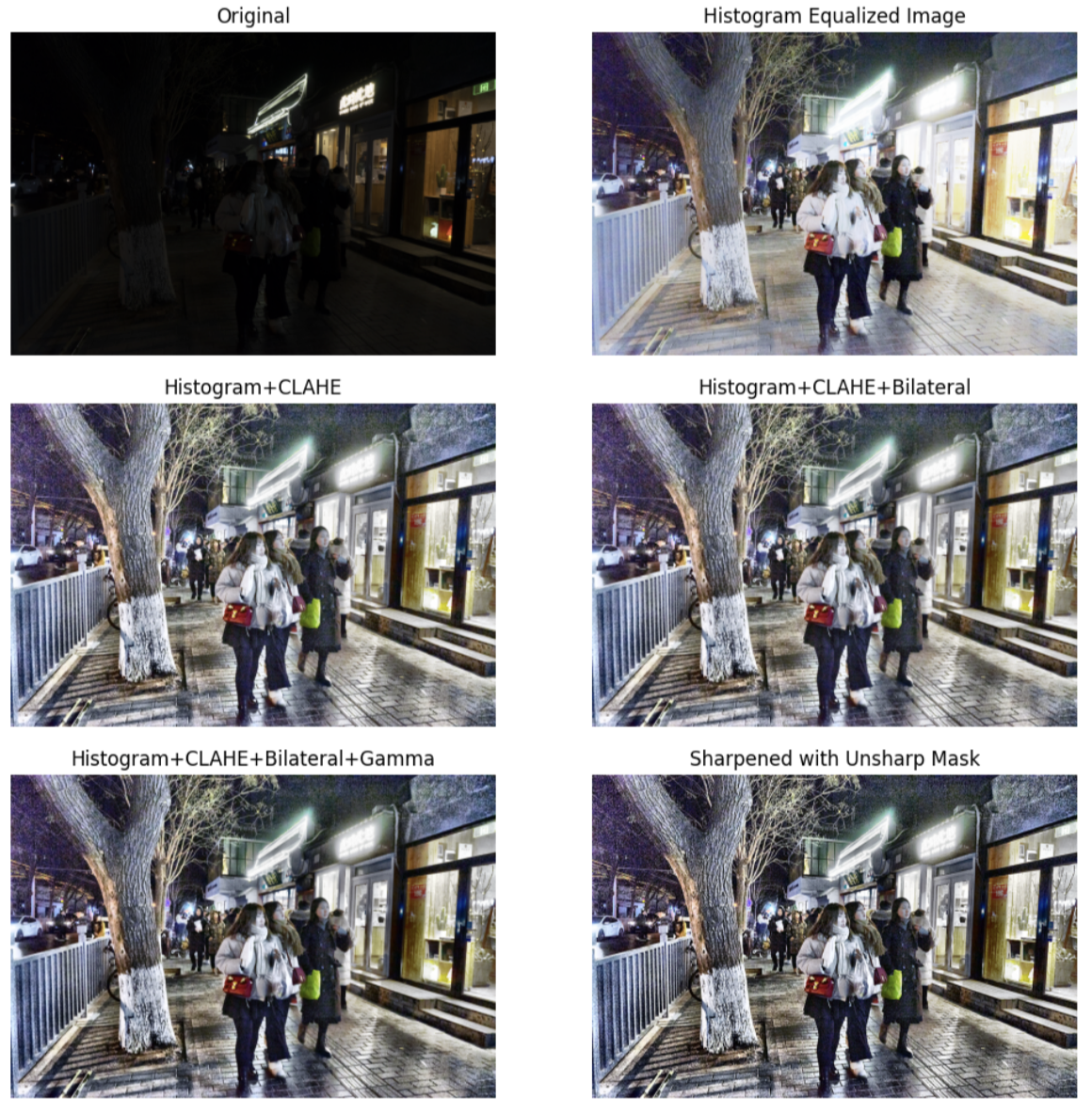



**Image 6:**

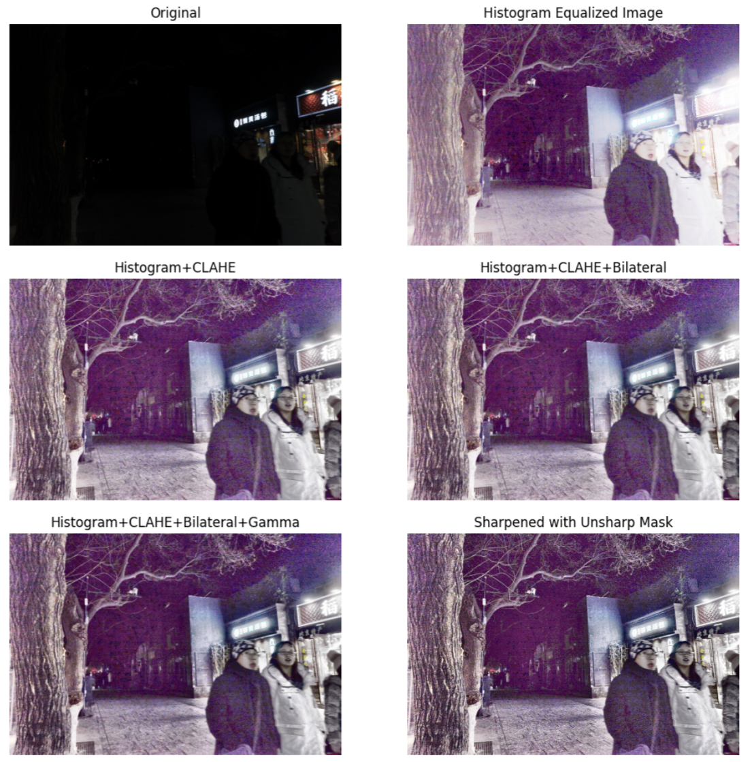



**Performance Metrics:**

**1. Entropy:**

Entropy is a statistical measure used in image processing to quantify the amount of information or randomness present in an image. It helps in determining the complexity or richness of the visual content. The higher the entropy, the more varied the pixel intensities, indicating a complex or detailed image, while lower entropy suggests a more uniform or simpler image.

**Ideal entropy range**:

* **Higher entropy** is generally better as it means more detail is present, but excessively high entropy can indicate noise.
* A **balanced range**: Entropy values typically range from **4 to 7** for most high-detail images (on an 8-bit grayscale scale, where 8 is the theoretical maximum entropy).
* **Low entropy (<3)**: May indicate an image is too uniform or blurry, lacking detail.
* **Very high entropy (>7)**: May suggest the image has too much noise.

**Original Image:**

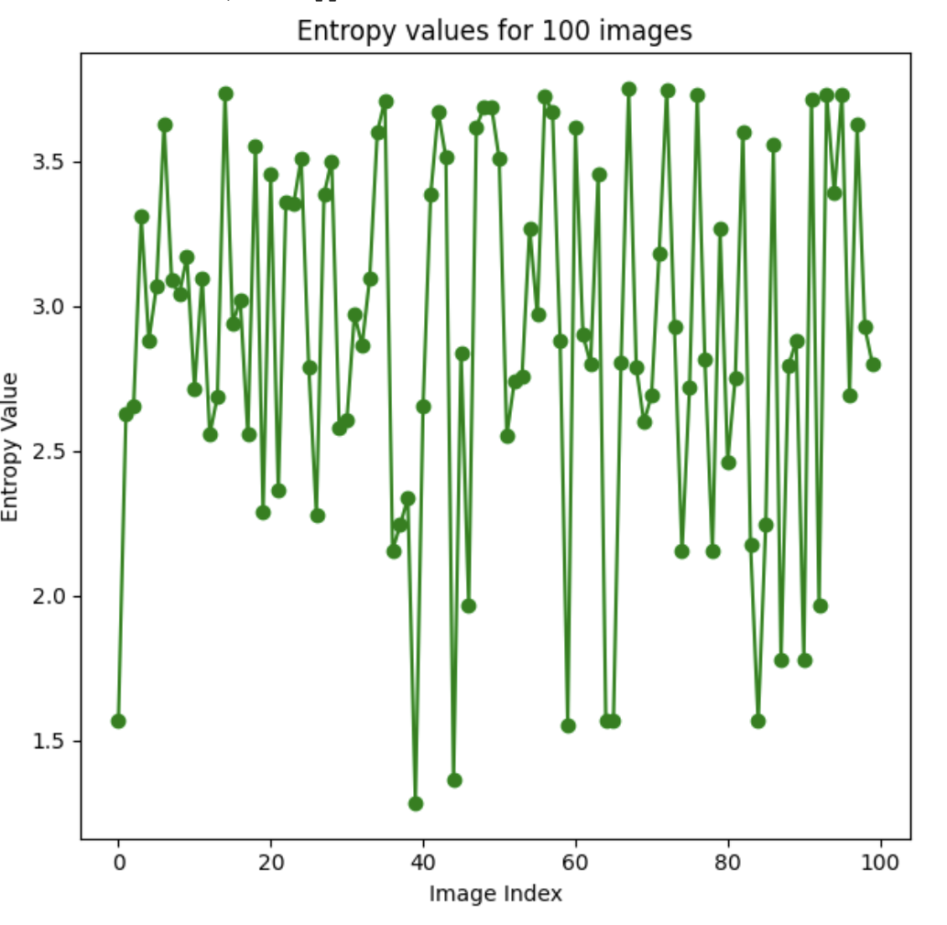

**Enhanced Image:**

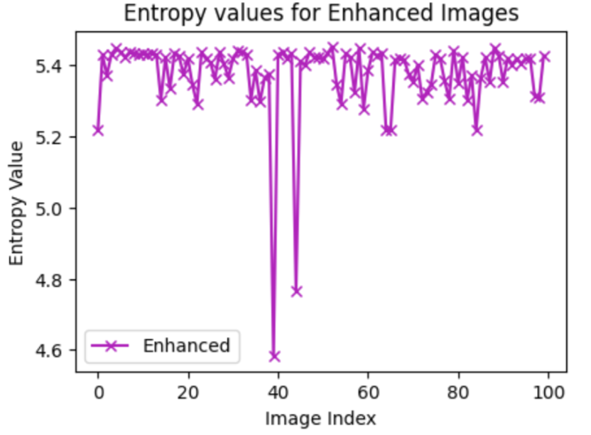

**2. Laplacian Variance:**

The Laplace of an image is a second-order derivative that highlights regions of rapid intensity change, i.e., edges. The Laplacian variance measures the variance of these Laplacian values and is used to assess the sharpness of an image. A higher Laplacian variance typically corresponds to a sharper image, whereas a lower variance indicates a smoother or blurred image

**Ideal Range**:

* **0 - 100**: Very blurry image. Almost no detectable edges or details.
* **100 - 500**: Blurry image. Edges are minimal, and details are soft.
* **500 - 1000**: Slightly blurry. Some edges present but still lacking in fine detail.
* **1000 - 5000**: Moderately sharp. The image has more distinct edges and details.
* **5000 - 10000**: Sharp. Edges are well-defined, and details are clear.
* **10000 - 20000**: Very sharp. The image is crisp with many fine details and textures.
* **20000 - 50000**: Extremely sharp. This level is often reached with very high-resolution images or highly textured scenes.

**Caution with High Values (>50,000)**: Very high Laplacian variance could also mean that the image contains significant noise, which could artificially inflate the sharpness metric. In such cases, while the edges may seem pronounced, the overall quality could be degraded by noise.

**Original Image:**

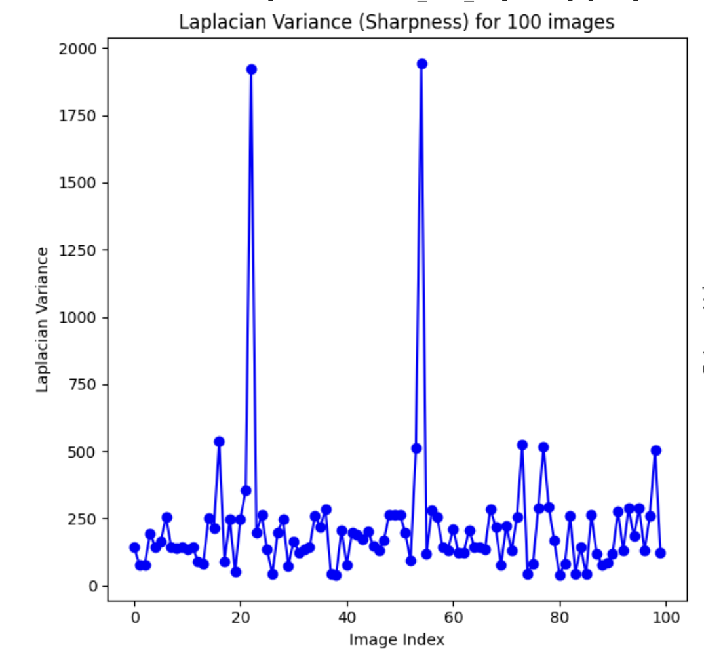

**Enhanced Image:**

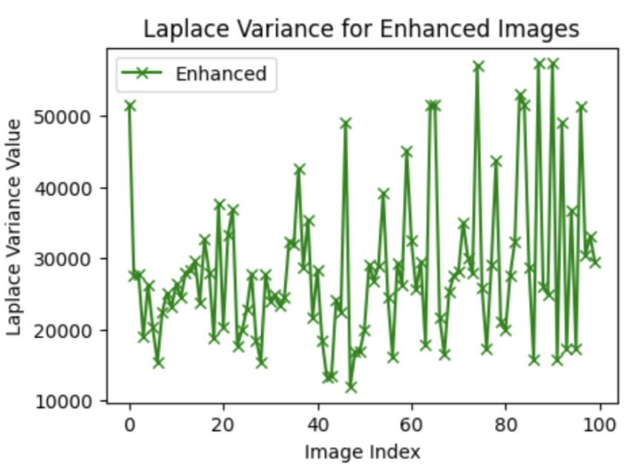

**Conclusion:**

To sum up, the visual quality of the photos is greatly enhanced by the employed image enhancement techniques, such as histogram equalization, CLAHE (Contrast Limited Adaptive Histogram Equalization), bilateral filtering, gamma correction and unsharp masking . While histogram equalization improves the overall contrast by spreading pixel intensity values, CLAHE further refines the contrast in limited places to prevent over-amplification of noise. A cleaner image is produced by the bilateral filter's efficient noise reduction combined with the preservation of crucial edge features. Gamma correction modifies brightness to keep the improved photographs looking realistic. Finally, unsharp masking highlights the image details and promotes better visual interpretation and analysis. The performance of the enhancement techniques are measured by metrics like Entropy and Laplace Variance.